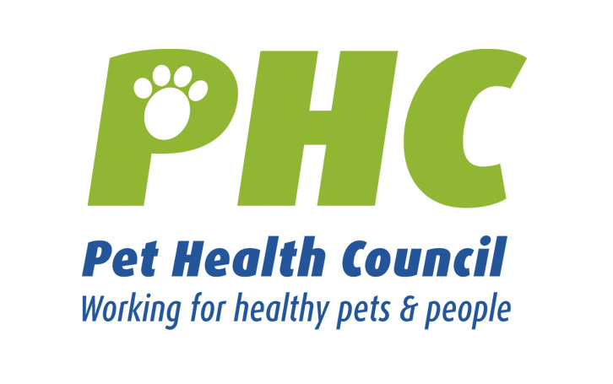PET HEALTH MATTERS
www.pethealthcouncil.co.uk

Keeping pets safe during the firework season

The Pet Health Council (PHC) is urging people to ensure that their pets remain safe and happy during the firework season. All domesticated animals, but dogs in particular, can get extremely stressed by the unusual sights, sounds and smells produced by fireworks – no surprise when you think how much more powerful their sense of hearing and smell can be. This can lead to anxiety which could cause odd behaviour such as howling, shaking and trembling. More acute symptoms can include diarrhoea, loss of bladder control and a sudden urge to escape or hide.

To keep your pets happy whilst you’re out having fun, the PHC has compiled 10 top tips for you to ensure that you are taking special care of your pets during and after the fireworks season.

1. Keep pets indoors – perhaps set up a room exclusively for your pet. Include their favourite blanket or toy and a special treat. Small pets such as rabbits and guinea pigs can be brought indoors, or their hutches moved into sheds or garages (but be careful they are not exposed to toxic chemicals / petrol fumes / exhaust gases).

2. Help your pet with pheromones. They can be used against anxiety and fear-related behaviours in dogs. Two weeks before the start of the firework season, switch on a DAP (Dog Appeasing Pheromones) diffuser in your pet’s favourite room. Leave the diffuser on at all times and remove approximately two weeks after the event. Alternatively, you can use a DAP spray. The spray can be applied directly to bedding. For cats, a similar product that contains cats facial pheromones is available.

3. Similarly you could try Homeopathy; for animals with a fear of noise nux vom and phosphorous are useful and available over the counter. Bach Flower Remedies can also be used, for the animal that dislikes loud noises Mimulus or to calm them use rescue remedy - a couple of drops to a pets drinking water. Please consult your pharmacist or vet before administering any of the above.
4. Keeping a television or radio on will create familiar sounds and distractions for your pet. Ensure it’s not so loud that it causes discomfort. Keep curtains closed.

5. Ensure that young children are aware of the dangers of fireworks – not only to themselves – but also to your pets. They might not realise that your dog doesn’t find a sparkler as fascinating as they do, or that the dog may not realise how hot the sparkler is.

6. If you are going to a specific venue to view fireworks, it is strongly recommended that you do not take your dog along. All pets are in danger of standing on, or picking up spent fireworks which can cause painful burns to paws and mouth.

7. Dog-nappers may see bonfire night – where many people leave their pets on their own to attend displays – as a unique opportunity. Leaving lights and radios on in your house will serve as an added discouragement.

8. Make sure that your garden perimeters are secure and all gates are locked to prevent your pet from escaping. Remember that dogs have the ability to jump over high fences and if they are scared they may even try to escape from high windows. Ensure ALL windows are closed.

9. Another good precaution is to make sure that your pet is wearing a collar and identity tag; remember this is a legal requirement. It is also strongly recommended you get your pet microchipped – that way they can always be traced back to you should they go missing. Just remember to keep your contact details up to date on the database.

10. If your pet does get lost, do not panic. There are a number of people that you can contact and it might be worth keeping their details close to hand; dog wardens, the police, local vets, boarding kennels, pet shops. Having up to date photos of your pets will help to identify them if they do escape plus they can be used in flyers and posters. Be prepared to provide a detailed description of your pet.

